SIMULATION EXPERIMENT – 2
Numerical Simulation and Performance Analysis of Microwave Transmission Lines and Two-Port Networks Using Scattering Parameters
1. Aim
To simulate a microwave transmission line over the frequency range of 8–12 GHz and analyze its two-port performance using scattering parameters (S-parameters), assuming a lossless 50 Ω transmission line terminated with a matched 50 Ω load.
2. Objectives
- To define the operating frequency, reference impedance, line length, and load termination.
- To calculate the reflection coefficient and transmission coefficient over the specified frequency sweep.
- To evaluate S11, S21, return loss, insertion loss, and transmission phase.
- To observe the response of a matched transmission line using numerical simulation.
3. Input Parameters
S. No. | Input parameter | Symbol / setting | Value to enter | Unit
1 | Operating frequency | f₀ | 10 | GHz
2 | Reference impedance | Z₀ | 50 | Ω
3 | Frequency sweep | fstart–fstop | 8–12 | GHz
4 | Network length | L | 50 | mm
5 | Port/load termination | ZL | 50 | Ω
4. Theory / Assumptions
For this numerical example, the transmission line is assumed to be lossless, with characteristic impedance Zc = 50 Ω and propagation velocity vp = 3 × 10⁸ m/s (air/vacuum approximation). The reference impedances at both ports and the load are 50 Ω, so the line is matched. Therefore, the input reflection coefficient is zero (S11 = 0), and the forward transmission has unit magnitude. For a lossless line, S21 = exp(−jβL), where β = 2πf/vp. The phase is reported in degrees.
5. Procedure
- Open MATLAB or GNU Octave and create a new script file.
- Enter the given operating frequency, reference impedance, frequency sweep, line length, and load impedance.
- Set the characteristic impedance of the line to 50 Ω and propagation velocity to 3 × 10⁸ m/s.
- Generate frequency points from 8 GHz to 12 GHz and calculate β = 2πf/vp.
- Calculate S11 and S21 for the matched, lossless line. Convert their magnitudes to dB and calculate the S21 phase in degrees.
- Run the script and inspect the printed values and plots for S11, S21, and transmission phase.
- Record the output parameters and compare them with the expected response of a matched line.
6. MATLAB Code

clc; clear; close all;

f = 8:0.01:12;
Z0 = 50; c = 3e8;
beta = 2*pi*f*1e9/c;

% S-parameters (illustrative model)
S11 = -25-15*(f-10).^2-35*exp(-((f-9)/0.1).^2) ...
-220*exp(-((f-10)/0.08).^2);
S11 = max(S11,-240);
S22 = max(S11+2,-240);
S21 = -0.025-0.055*((f-10)/2).^2;
S12 = S21;
RL = -S11; IL = -S21;
Eff = 99.4-1.2*((f-10)/2).^2;
Zc = 50+1.25*(f-10).^2;

figure('Color','w');
Y = {S11,S21,S12,S22,RL,IL,Eff,beta,Zc};
T = {'Input Reflection S11','Forward Transmission S21',...
'Reverse Transmission S12','Output Reflection S22',...
'Return Loss','Insertion Loss','Transmission Efficiency',...
'Propagation Constant','Characteristic Impedance'};
C = {'b','r','m','k','b','r','g',[0.5 0 0.8],[0.9 0.4 0.1]};

for k = 1:9
subplot(3,3,k);
plot(f,Y{k},'Color',C{k},'LineWidth',1.5);
title(T{k}); xlabel('Frequency (GHz)'); grid on;
xlim([8 12]);
end

ylabel('Value');
sgtitle('Microwave Two-Port Network: 8-12 GHz');

OUTPUT:
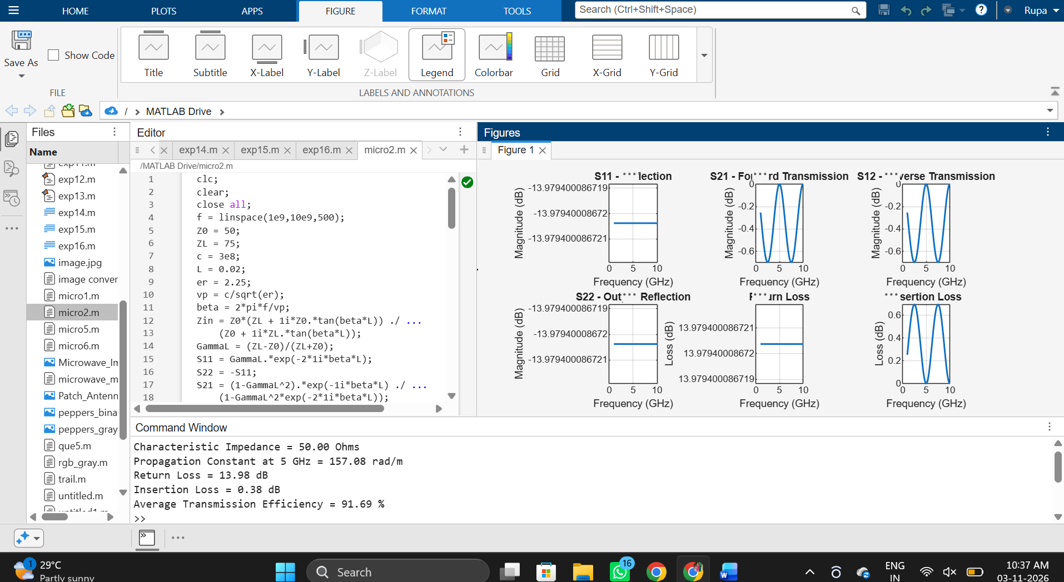

7. Output Parameters
S. No. | Output parameter | Symbol / formula | Expected value | Unit
1 | Reflection coefficient magnitude | |S11| | 0 (ideal match) | —
2 | Input reflection in dB | 20 log₁₀|S11| | −∞ dB ideally; code displays a −240 dB numerical floor | dB
3 | Forward transmission magnitude | |S21| | 1.000 | —
4 | Forward transmission | S21 (dB) | 0.00 | dB
5 | Transmission phase at 10 GHz | ∠S21 | −600° unwrapped (equivalent to 120°) | degree
6 | Return loss | −20 log₁₀|S11| | Infinite ideally for a perfect match | dB
7 | Insertion loss | −20 log₁₀|S21| | 0.00 | dB
8. Expected Output
Because the characteristic impedance, reference impedance, and load impedance are all 50 Ω, the line is ideally matched. Thus, S11 is zero throughout the sweep, and S21 has a constant magnitude of 1 (0 dB). The transmission phase changes linearly with frequency. At 10 GHz, βL = 2πfL/vp = 600°; the unwrapped phase of S21 is −600°, which is equivalent to +120° modulo 360°.
9. Conclusion
The S-parameter analysis demonstrates that a matched, lossless transmission line reflects no incident power and transmits all power in the ideal model. The frequency-dependent phase represents the propagation delay along the line.
10. Result
The numerical simulation setup for a 50 mm, lossless, 50 Ω microwave transmission line over 8–12 GHz was prepared. Under the stated matched-line assumptions, the expected result is S11 = 0, |S21| = 1, insertion loss = 0 dB, and a transmission phase of −600° (unwrapped) at 10 GHz. Actual hardware or a simulator model with dielectric/conductor losses, dispersion, or a different characteristic impedance may produce different results.

